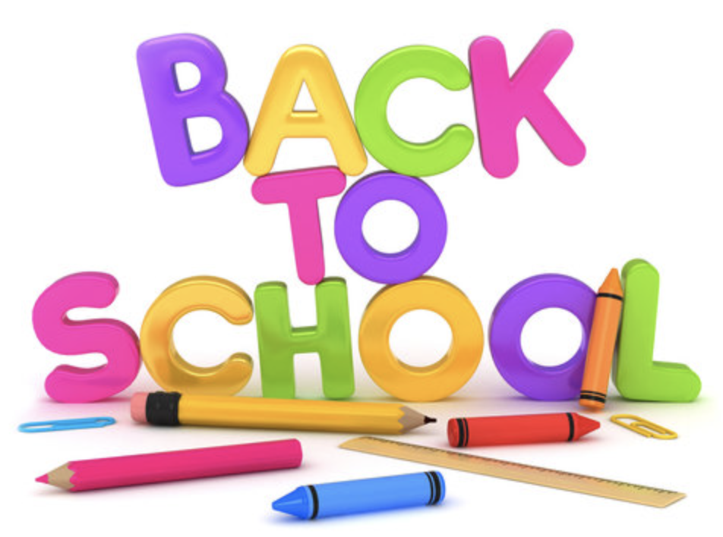 

Dear P.S. 108 Families,

We hope that everyone had a healthy, restful and enjoyable summer break. We are excited to welcome you to the start of the 2023-2024 school year! We are looking forward to having our students back in the building for another successful school year! Our days and weeks will be filled with wonderful experiences and opportunities for learning and growing both academically and socially.

The first day of school will be on ***Thursday, September 7, 2023.*** PLEASE NOTE THAT SCHOOL HOURS HAVE CHANGED THIS YEAR. The school day will be from **8:00am- 2:20pm**.

In order to be successful at keeping the communication between home and school open, it is important to make sure the school has updated phone numbers and email addresses. If at any time your information changes, please be sure to update it with the school and your child’s teacher immediately. All communication is sent through our school app & email.

If you have not already done so, please be sure to register with NYCSA <https://mystudent.nyc/> for access to important school documents such as report cards, tax forms and transportation.

**To order your child’s school uniform visit** [www.SmoothUSA.com/PS108x](https://nam10.safelinks.protection.outlook.com/?url=http%3A%2F%2Fwww.smoothusa.com%2FPS108x&data=05%7C01%7Cscedrolamustafa%40schools.nyc.gov%7Caad634433c4741b916f008da641dd884%7C18492cb7ef45456185710c42e5f7ac07%7C0%7C0%7C637932376727638945%7CUnknown%7CTWFpbGZsb3d8eyJWIjoiMC4wLjAwMDAiLCJQIjoiV2luMzIiLCJBTiI6Ik1haWwiLCJXVCI6Mn0%3D%7C3000%7C%7C%7C&sdata=QPeMZbixb3P2NzXiLILg02KNTtJFGE22WrgHucCl8rk%3D&reserved=0)

**To order school supplies:**

[**https://schooltoolbox.com/school-supplies/school/list-boxes/?schoolId=681**](https://schooltoolbox.com/school-supplies/school/list-boxes/?schoolId=68193)

**Morning Arrival**

Students should arrive to school no later than 8:00am. The school building will open for breakfast at 7:30am. For families who are driving to school, we will have a drop & go system. Students should be ready to go by the time you pull up to the front of the building. All students will enter the main entrance on Neill Avenue for morning arrival. Students in K-2nd grade should attach the enclosed tag to their backpack.

**Dismissal**

**Dismissal is at 2:20pm**.

*Students in Pre-K – 2nd grade will be dismissed out of Exit 2 and walk around towards

Herring Avenue. Parents are encouraged to spread out around the corner to ensure a safe dismissal.

*Students in Grade 3-5 will dismiss from Exit 1 and line up along the front gate on Neill Avenue

*\*The school building will be open*

*August 28-September 1st from 9am-1pm if you would like to drop off your child’s supplies. Please label all bags with your child’s name & class.\**

**Be sure to download our school app for daily updates and school news!**

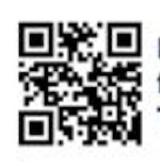

**Please use this guide when deciding whether or not to send your child to school.**

