**April’s Problem of the Month**

**Grade 3**

A gardener is drawing plans for a new yard. She creates the picture below to represent the size and shape of the new lawn.

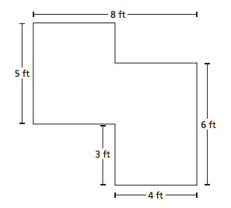

How can the gardener find the total area of the new lawn? Describe the process she can use. What is the total area of the new lawn?

***Be sure to show your work and explain your solution! Answers must be written on loose leaf paper. Solutions are due Wednesday, April 29th.***

**3.MD.7d**