June 2025

Dear Future Sixth Grade Families,

**Welcome to Sixth Grade!**

In order to help you prepare for an exciting year of learning, here are some supplies you will need for the 6th grade school year.

**Please bring these items to school with you on the first day.** ​Kindly label your notebooks and folders, all other supplies are community supplies.

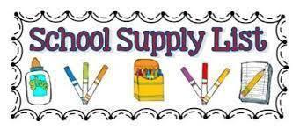

| **All subjects**   * 1 pencil case zipper pouch * 1 package of highlighters * 1 scissor * 1 pack of erasers * 4 packages of pre sharpened #2 Ticonderoga pencils * 1 package of looseleaf (wide ruled) * 1 package of construction paper * 1 set of headphones * 1 package of glue sticks * 1 package of dry erase markers * 4 rolls of paper towels * 4 boxes of tissues * 4 containers of Clorox disinfecting wipes * 2 bottle of hand sanitizer * 2 bottles of hand disinfectant soap | **Math**   * 1 plastic folder * 1 composition notebook * 1 package of graph paper * 1 ruler   **ELA**   * 2 composition notebooks * 1 plastic folder * 1 color variety pack of post its * 1 pack of index cards   **Science**   * 1 plastic folder * 1 composition notebook   **Social Studies**   * 1 plastic folder * 1 composition notebook   ***\*Students will be given a Macbook to carry to and from school. We strongly suggest you buy a carry case to prevent damage.***  ***\*Having a reusable water bottle will be helpful throughout the year to eliminate the need to frequently visit the water fountain. Make sure it is a snap top and not a straw top- to prevent spills.*** |
| --- | --- |